How-To

Receive NB-IoT data from the T-Mobile / SODAQ board

via the MQTT API of the All Things Talk Platform
Herbert Schermerhorn, Premium Business Consultants, herbert.schermerhorn@premium.nl

Using the MQTT API of the All Things Talk Platform.

When you are the lucky owner of a SODAQ (development) NB-IoT Board, connected to the T-Mobile Narrow Band infrastructure, your data will be delivered to the All Things Talk Platform.
A disadvantage of the using the Web-GUI of the All Things Talk Platform for receiving data from your SODAQ T-Mobile NB-IoT Board, is that it’s impossible to import or use this data in your own applications. Luckily, the all things talk platform also has an MQTT API with which it is possible to do so.
This API can be used with any MQTT Client, by either installing MQTT yourself, or by using a MQTT client as MQTTLens or the MQTT Client within Node-Red. This short article explains how you set up a working MQTT interface.

As a start
It is assumed that you have a working SODAQ / T-Mobile NB-IoT board and that you have a registered device and asset on the All Things Talk Platform. Furthermore, it is assumed that you are familiar with MQTT.
For the reception of MQTT data-feeds from the All Things Talk MQTT API you do not need to install an MQTT Server. A MQTT Client installed on your PC is sufficient. In this How-To, we will use Google’s MQTTLens and the Node Red MQTT Client as an example.
The example with MQTTLens is primarily meant to show how to set up the MQTT Connection. With MQTT Lens as MQTT Client you can set up the MQTT connection and can verify if the connection works. But you are still not capable of processing the data received. Using a MQTT Client within Node Red does enable data processing.

Gathering the information
First, we’ll need some information on how our SODAQ board is registered on the All Things Talk Platform. Go to https://maker.allthingstalk.com , login and select the asset from which you want to receive the data.
In the devices screen, click on your asset:
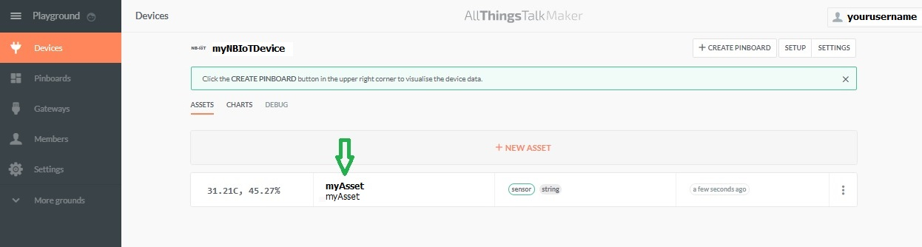
You will get the Asset detail screen.
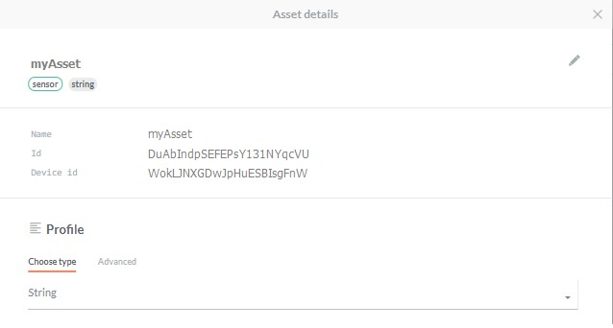
From this screen, you need the Asset name and Device ID:
Data needed | Example Value (is specific for your application)
Asset name | myAsset
Device id | WokLJNXGDwJpHuESBIsgFnW

Next, close this window and go to Settings and Authentication. You will get this screen:
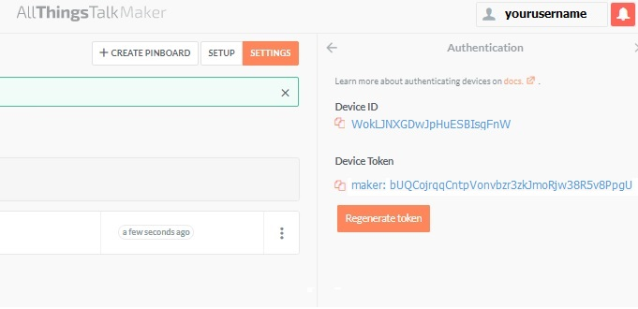
From this screen, you need the Device Token.
Data needed | Example Value (is specific for your application)
Device Token | maker: bUQCojrqqCntpVonvbzr3zkJmoRjw38R5v8PpgU
Note: The Device token string includes the string “maker:”
Furthermore, you need:
Data needed | Value
Hostname of the AllThingsTalk MQTT Server | api.allthingstalk.io
Port of that server | 1883

To be able to listen to / receive the data from the All Things Talk Platform, you need to make a connection to that platform, using a MQTT Client. For setting up the MQTT Client and the connection, you additionally need.
A name for the Connection.
Connection name | Value
Format | Choose any name
Example | myATTMQTTConnection

A MQTT Topic to subscribe to. Using this “topic”, your MQTT Client gets subscribed on all data feeds towards that specific topic (being your data stream, defined by device id and asset name).
MQTT Topic | Value
Format | device/<device_id>/asset/<asset name>/feed
In example | device/WokLJNXGDwJpHuESBIsgFnW/asset/myNBIOTasset/feed

An Id for your MQTT Client (e.g. the MQTTLens client installed on your PC). It’s this client, which will make the MQTT connection to the All Things Talk Platform.
Client ID | Value
Format | Choose any name. Some MQTT Clients can auto-generate a Client id
Example | Itsme

Installing MQTT Lens as an MQTT Client

In this How-To, the use Google’s MQTTLens an MQTT Client is described. MQTTLens is a one-minute install. If not already installed, download and install MQTTLens via:
https://chrome.google.com/webstore/detail/mqttlens/hemojaaeigabkbcookmlgmdigohjobjm/related
And Click “Start App” (APP started).

MQTT will start. Next, Click “+“ under Connections to create a new connection.
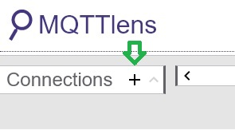

Adding a new Connection
In the screen, fill-in the information requested, using the data from the previous chapters. Note that:
- The usename is your Device-Token
- The password an be any string of characters. The All Thing Talk Platform does not validate the password, but the pasword value must not be empty.
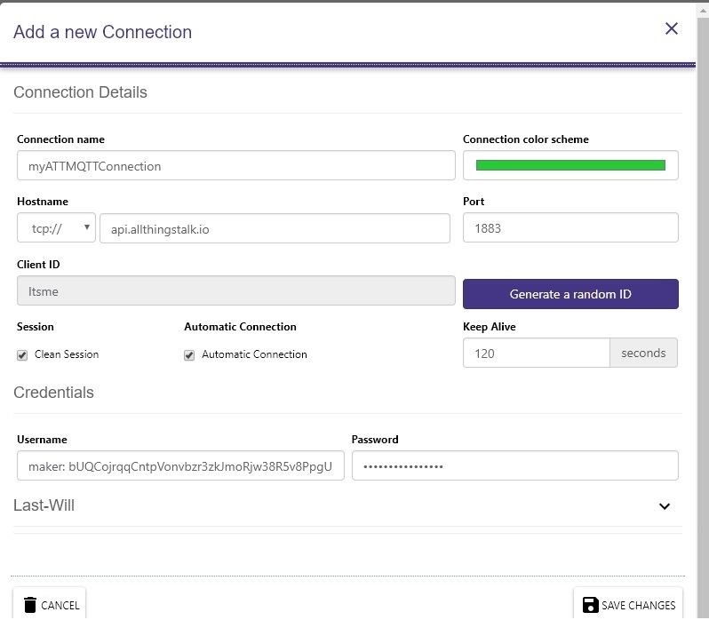

Subscribing to the topic (data feed)

Now the connection is defined and you can subscripe to a topic. We have defined the topic definition earlier. Register that value under “Subscribe” and press the “Subscribe” button.
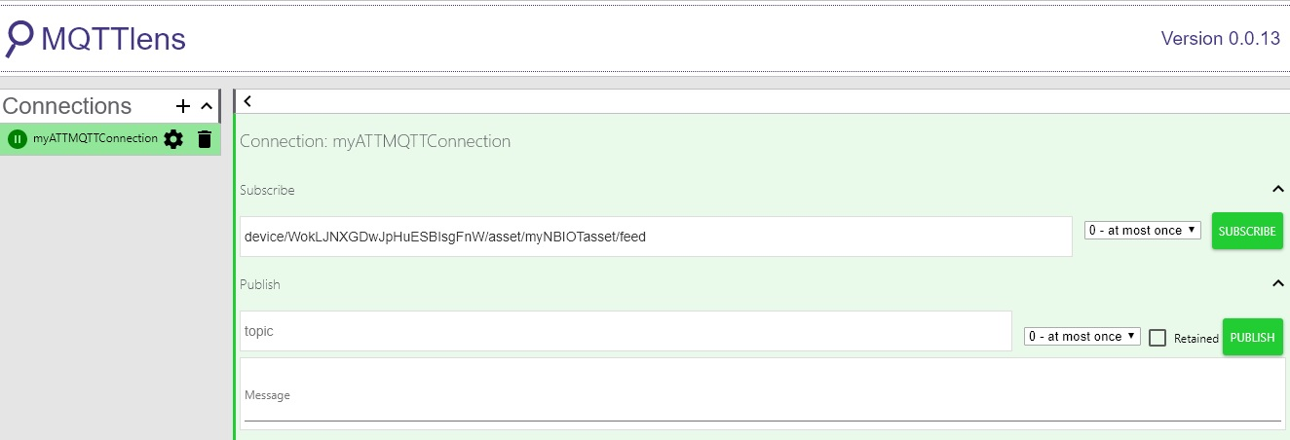

From that moment on, our MQTT Client MQTTLens will receive all messages (payloads) addressed to the MQTT topic “device/WokLJNXGDwJpHuESBIsgFnW/asset/myAsset/feed” from the All Things Talk MQTT Server. That particular topic is related to our data, since it refers to our Device id and Asset name.
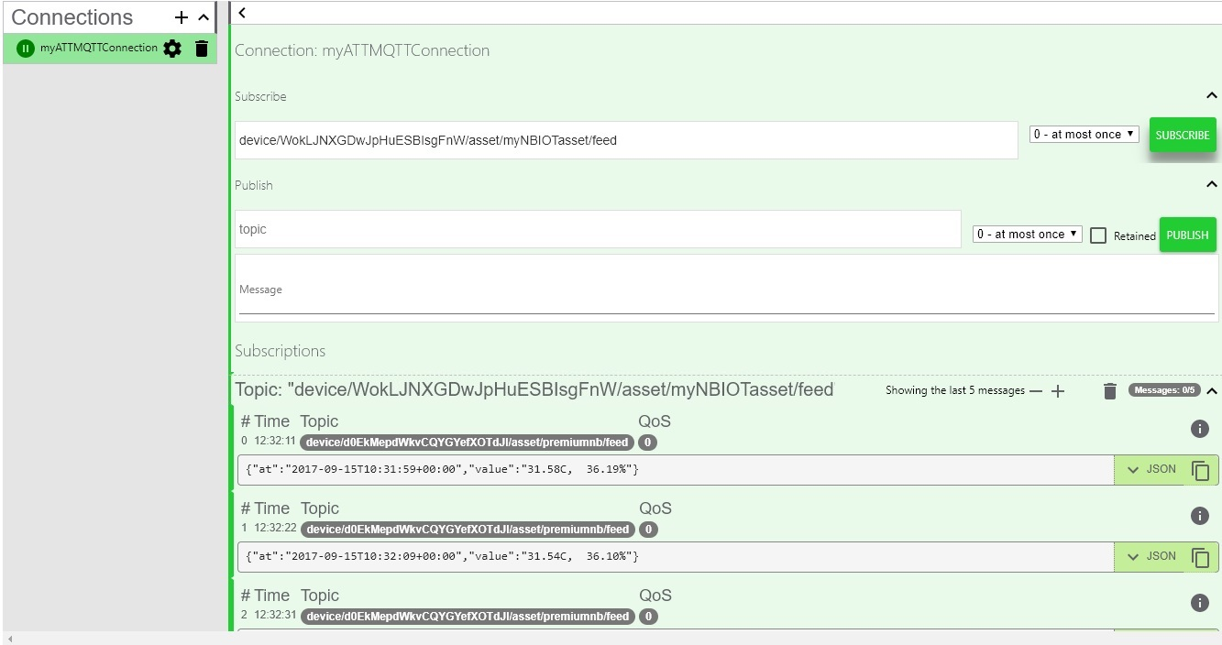

Using Node-Red’s MQTT capabilities

If you use MQTT within Node Red, you can not only view that data, but you can use the data received within your Node Red application. It is assumed that you have a working version of Node Red installed.
To use MQTT within Node Red, you should drag a MQTT input node on the CANVAS.

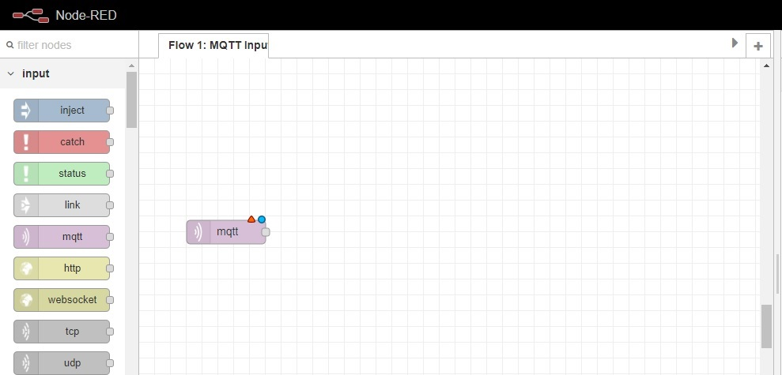

Next, click on the node and open the “Server” field after clicking on the edit pencil.
First, select the “Connection” tab en fill in your Server Name, Port number and your Client ID
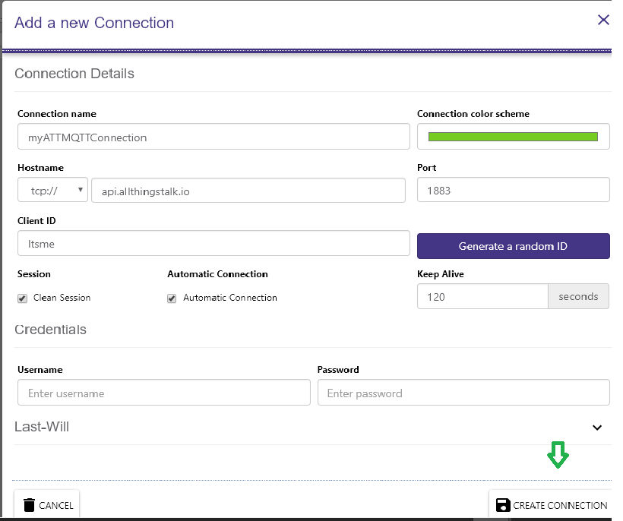

Next, open the Security tab and fill in the username (the device token) and the password. (can be any string since All Things Talk does not validate on password, but can’t be empty).

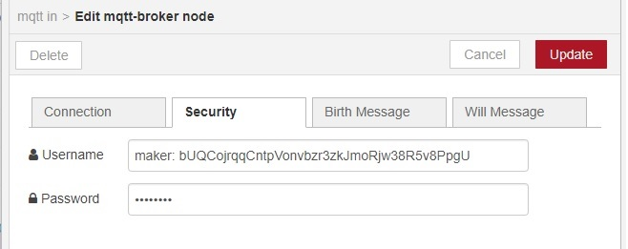

Now the configuration of the MQTT input node is ready, click on Update to save the MQTT node and click “Deploy” to Deploy.
There will be a green circle with the word “connected” under the MQTT node on the canvas if the connection to the All Things Talk MQTT Server is successfully.
Next, you can add a green debug output node and connect it to the MQTT node. Deploy this new situation. Take care you have activated the debug node by pressing the right end tab of the debug node (making it dark green filled). From this moment on, the data received will be visible in the Debug Screen at the right.

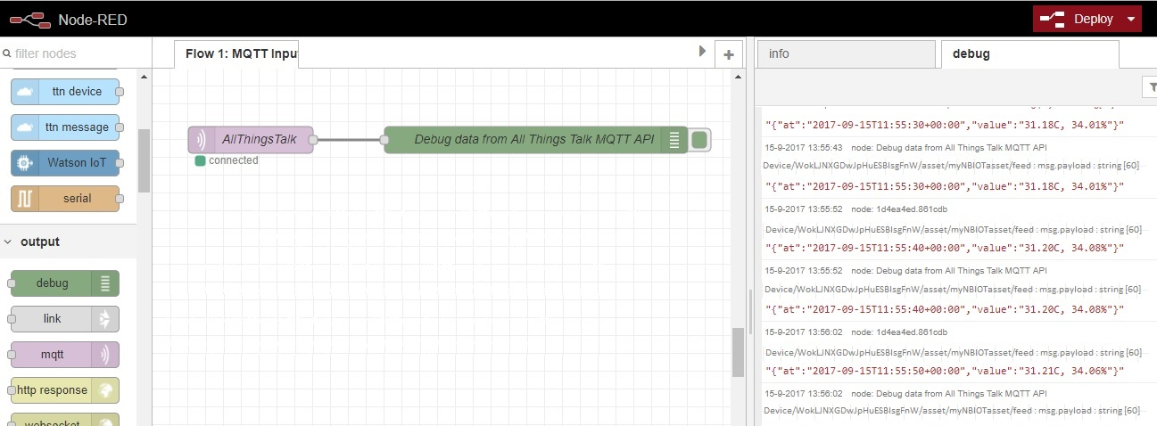

In fact, the data received by the Node-Red client, is passed as “msg.payload” to the debug node.
Now you have come this far, it is rather easy to add function nodes and e.g. a MySQL node, to store the received data. Or process the data other ways.
Voila, data integration between the All Things Talk platform which is used for T-Mobile NB-IoT and your application, using MQTT.

#

